FLOOD SCENARIO
The Tech team projects a heightened risk of flooding during the summer of 2025 due to a combination of climatic and meteorological factors. The anticipated development of the La Niña phenomenon and a transition of the Indian Ocean Dipole (IOD) toward a positive phase are expected to intensify monsoon rainfall. Elevated temperatures over the Tibetan Plateau are likely to create a low-pressure system over the upper Indus catchment, drawing stronger atmospheric pressure systems from the Arabian Sea and Bay of Bengal, which will fuel heavy precipitation. Additionally, an active Western Disturbance system, coinciding with the monsoon trough and glacial melt, is predicted to cause heavy rains in western river catchments, including the Kabul River, as well as hill torrents in Rajanpur, Dera Ghazi Khan and Kirthar Range. This convergence of climatic factors poses a significant risk of widespread inundation across Khyber Pakhtunkhwa (KP), western part of Punjab and part of Sindh as well.
 | DEW Issue Date | Validity | Indicator Monitored |  | Remarks
 | 3rd March  (D-6 Months) | March - September | La Niña development, IOD transition to positive phase, higher Tibetan Plateau temperatures, reduced snow cover, early warning of intensified monsoon rainfall |  | Initial projections highlight climatic factors leading to increased flood risk during the summer of 2025. Relevant Depts.  Should Focus on preparedness for intensified monsoon and potential flooding in  western rivers.
 | 1 June  (D-2 Months) | June - August | High Sea Surface Temperature in the Mediterranean and Caspian Sea activating western disturbance, intensified monsoon trough due to placement of sub- tropical jet stream over Tibetan plateau, glacial melt, and convective precipitation along hill torrents of Punjab and Kirthar Range. |  | Seasonal update confirms enhanced flood risk due to active weather systems and higher atmospheric moisture.
 | 13th July  (D-14 Days) | 27 July-  3 August | Western Disturbances coinciding with peak monsoon activity, active rainfall zone is placed over north Arabian sea, increased river flows due to glacial melt & confluence of western and monsoon disturbance, and activation of hill torrents in Punjab and Kirthar Range. |  | Short-term warning of peak flood risk in western river catchments and areas prone to hill torrents of Punjab and Kirthar Range. Max Reservoir Capacity of Tarbela Dam expected in coming days.
 | 20th July  (D-07 Days) | 27 July-  3 August | Heavy rainfall in Upper Indus Basin, higher river flows due to glacial melt, Max Tarbela Reservoir Capacity, Low-Pressure System developed over KP, Punjab and upper Sindh. Inundation risks in critical districts of River Indus & its tributaries. |  | Heavy rains on upper catchment areas and high river flows escalate flood hazards. Max Reservoir Level of Tarbela dam is  Localized Cloud burst are likely to happen in Punjab and Kirthar Range hill torrents. High Flows in Lower River Indus & Tributaries are going to expected in coming week.
Scenario (Riverine Flooding)
Type of Hazard |  |  |  | Riverine Flooding
Intensity of Flows |  |  |  | - Low to Medium Flows in Indus River up to Taunsa Barrage (300,000 cusecs)  - Activation of Punjab and Kirthar Hill Torrents (1,25,000 cusecs)  - High Flows in Indus River at Sukkur Barrage (5,00,000 cusecs)
Duration of disaster event and Intensity |  |  |  | 27th July- 3rd August 2025 (Riverine Flooding)

There are 2.2 million people which are within the exposure zone, with districts such as Kashmore, Ghotki, Sukkur, Shikarpur, Khairpur, Dadu and Naushero Feroz, Jamshoro, Larkana, Shaheed Benazirabad.

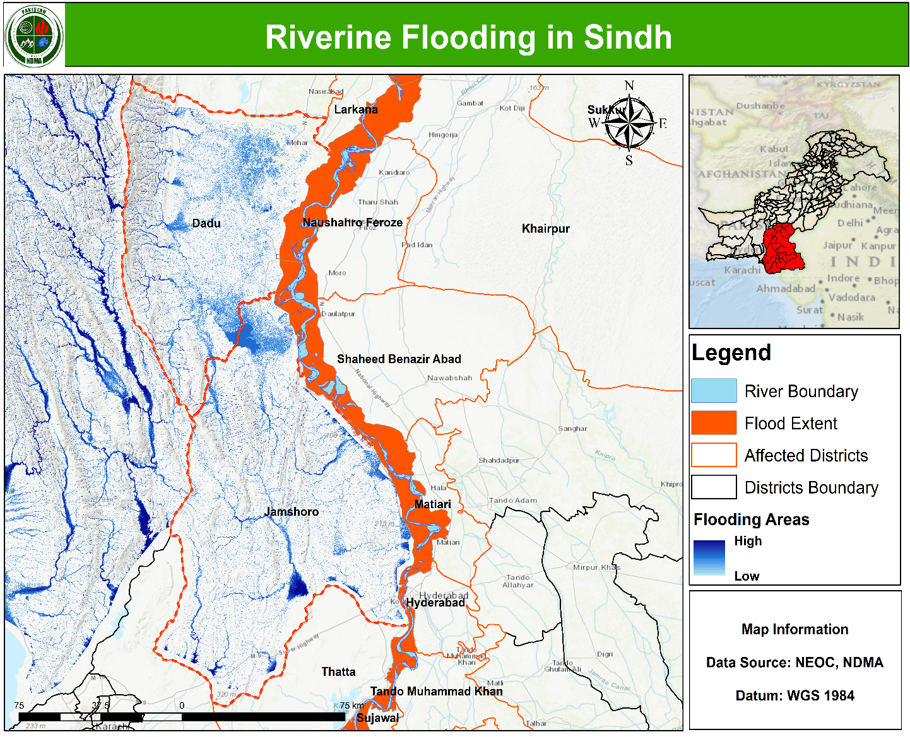

ARC Exposure
